3rd Spaces Group Limited
ORDER NUMBER |  |  |  |  | Order Quantity |  |  |  |  |  | Quantity of  Extra Fronts |  |  |  |  | Designed for: |  |  |  |  | BASE SIZE  W_____ X L_____ |  |  |  |  |  |  | Regular Order____  Rush Order____
Base type
——
Style  —— | 1、Left Crown |  |  |  |  | 2、Right Crown |  |  |  |  |  | 3、Center Crown |  |  |  | 4、Left Part |  |  |  | 5、Right Part |  |  |  | 6、Center Part |  |  |  |  | 7、Pompadour/ Freestyle
Style  —— | 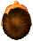 |  |  |  |  | 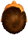 |  |  |  |  |  | 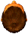 |  |  |  | 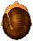 |  |  |  | 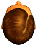 |  |  |  | 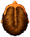 |  |  |  |  | 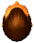
Waves  &  Curls |  |  |  |  |  |  |  | FRONT EDGE |  |  |  |  |  | FRONT（1） |  |  |  | TOP（2） |  | CROWN （3） |  |  |  | BACK （4） |  |  |  |  | SIDE（5） |  | TEMPLE（6）
Waves  &  Curls | Afro 2-4mm
Waves  &  Curls | Light Wave 25mm
Waves  &  Curls | Slight Wave 32mm
Waves  &  Curls | Straight 36mm
Waves  &  Curls | Other
Hair  Density | Density % |  |  |  |  |  |  | FRONT EDGE |  |  |  |  |  | FRONT（1） |  |  |  | TOP（2） |  | CROWN （3） |  |  |  | BACK（4） |  |  |  |  | SIDE（5） |  |  | TEMPLE（6）
Hair  Density | Extra Light 50%
Hair  Density | Light 80%
Hair  Density | Light-Medium 90%
Hair  Density | Medium 100%
Hair  Density | Medium-Heavy 120%
Hair  Density | Heavy 130%
Hair  Density | Extra heavy 150%
Hair  Density | Super Heavy 180%
 |  |  |  |  |  |  | FRONT EDGE |  |  |  |  |  | FRONT（1） |  |  |  | TOP（2） |  | CROWN（3） |  |  | BACK（4） |  |  |  | SIDES（5） |  |  |  | TEMPLES（6）
Hair Length
Extra Charges After 6”
Hair Type |  |  |  |  |  |  | Main Fiber 1. Indian_____% 2.Chinese____% 3.Synthetic____%
 |  |  |  |  |  |  | Grey Hair Selection: _____ 1、Synthetic 2、Yak 3、Human
____Total % of Grey  ____Extra % of Grey |  |  |  |  |  |  | FRONT EDGE |  |  |  |  |  | Front |  |  |  | Top |  | Crown |  |  | Temples |  |  | Sides |  |  |  |  | Back
 |  |  |  |  |  |  | + % |  |  |  |  |  | + % |  |  |  | + % |  | + % |  |  | + % |  |  | + % |  |  |  |  | + %
 |  |  |  |  |  |  |  |  |  | FRONT EDGE% |  |  |  |  | FRT% |  |  | TOP% |  |  | CRON% |  | TEMPLES% |  |  |  | SIDES% |  |  | BACK%
____Hi-light Color  ____Spot Color |  |  |  | Color Ring____
Hair samples
attached____
Base Hair Color |  |  |  | Color Ring____
Hair samples
attached____
Undervent  Density |  | ___Front only  ___All Around |  |  |  |  |  |  | ___1、Light  ___2、Medium  ___3、Heavy |  |  |  |  |  | Scalloped Front #____ |  |  |  |  |  |  |  | Special Instructions
 |  |  |  |  |  |  |  |  |  |  |  |  |  |  | 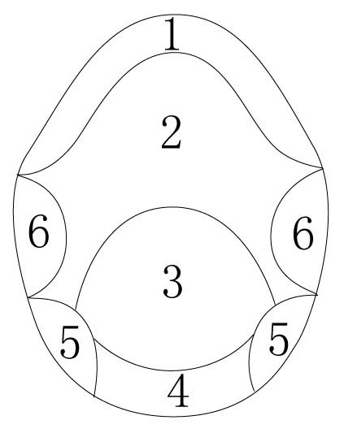
Baby Hair in Front |  |  |  |  | ___1. YES ____2. NO
Width of Lace Fronts
__1、1/8” __2、1/4” __3、1/2” __4、3/4” __5、1” __6、other____”
Base Color
__1. flesh __2. black __3. brown
__4. transparent __5. other
___ 1、Imprint Name & Date
___2、Enclose Extra Hair
E-mail: sales@hairmanufactory.com
CAP  SIZE |  |  | 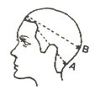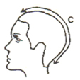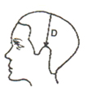  Circumference Front to Back Ear to Ear Over Top  A:__________ C:___________ D:_____________  B:__________

ORDERED
BY NAME
Email |  | Company
Address |  | Tel
Message

